(1)

(a)

> **ec1:=diff(x(t),t)=x(t)+4*y(t);**



> **ec2:=diff(y(t),t)=x(t)+y(t);**



> **dsolve({ec1,ec2},{x(t),y(t)});**



(b)

> **ec1:=diff(x(t),t)=2*x(t)-y(t);**



> **ec2:=diff(y(t),t)=x(t)+2*y(t);**



> **dsolve({ec1,ec2},{x(t),y(t)});**



(c)

> **ec1:=diff(x(t),t)=x(t)-y(t)+z(t);**



> **ec2:=diff(y(t),t)=x(t)+y(t)-z(t);**



> **ec3:=diff(z(t),t)=-y(t)+2*z(t);**



> dsolve({ec1,ec2,ec3},{x(t),y(t),z(t)});



(d)

> **ec1:=diff(x(t),t)=3*x(t)-y(t)+z(t);**



> **ec2:=diff(y(t),t)=2*x(t)+z(t);**



> **ec3:=diff(z(t),t)=x(t)-y(t)+2*z(t);**



> **dsolve({ec1,ec2,ec3},{x(t),y(t),z(t)});**



(e)

> **ec1:=diff(x(t),t)=5*x(t)+3*y(t)+1;**



> **ec2:=diff(y(t),t)=-6*x(t)-4*y(t)+exp(t);**



> **dsolve({ec1,ec2},{x(t),y(t)});**



(f)

> **ec1:=diff(x(t),t)=x(t)+3*y(t)+cos(t);**



> **ec2:=diff(y(t),t)=x(t)-y(t)+2*t;**



> **dsolve({ec1,ec2},{x(t),y(t)});**



(g)

> **ec1:=diff(x(t),t)=x(t)-2*y(t)-2*z(t)+exp(-t);**



> **ec2:=diff(y(t),t)=-2*x(t)+y(t)+2*z(t);**



> **ec3:=diff(z(t),t)=2*x(t)-y(t)-3*z(t)+exp(t);**



> **dsolve({ec1,ec2,ec3},{x(t),y(t),z(t)});**





(h)

> **ec1:=diff(x(t),t)=-x(t)+3*y(t)-4*z(t)+25*t;**



> **ec2:=diff(y(t),t)=-2*x(t)-6*z(t)+12*exp(t);**



> **ec3:=diff(z(t),t)=-2*x(t)-6*y(t)+6*z(t)+12;**



> **dsolve({ec1,ec2,ec3},{x(t),y(t),z(t)});**





(2)

(a)

> **sist:=diff(x(t),t)=x(t)+4*y(t),diff(y(t),t)=x(t)+y(t);**



> **cond_in:=x(0)=1,y(0)=2;**



> **xx1:=DEplot([sist],[x,y],t=-5..5,[[cond_in]], linecolor=blue,**

**scene=[t,x(t)]):**

>

**yy1:=DEplot([sist],[x,y],t=-5..5,[[cond_in]],linecolor=red,**

**scene=[t,y(t)]):**

> **display([xx1,yy1]);**

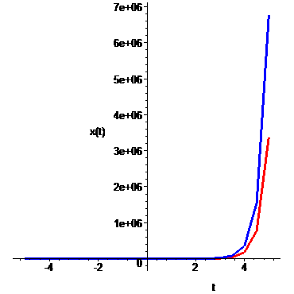

(b)

> **sist:=diff(x(t),t)=x(t)-y(t)+t+1,diff(y(t),t)=-2*x(t)+4*y(t)+exp(t);**



> **cond_in:=x(0)=0,y(0)=1;**



> **xx1:=DEplot([sist],[x,y],t=-5..5,[[cond_in]], linecolor=blue,**

**scene=[t,x(t)]):**

> **yy1:=DEplot([sist],[x,y],t=-5..5,[[cond_in]],linecolor=red,**

**scene=[t,y(t)]):**

> **display([xx1,yy1]);**

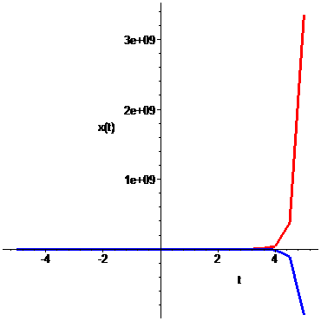

(c)

> **sist:=diff(x(t),t)=x(t)+2*y(t)+exp(-t),diff(y(t),t)=-2*x(t)+y(t)+1;**



> **cond_in:=x(0)=0,y(0)=1;**



> **xx1:=DEplot([sist],[x,y],t=-5..5,[[cond_in]], linecolor=blue,**

**scene=[t,x(t)]):**

> **yy1:=DEplot([sist],[x,y],t=-5..5,[[cond_in]],linecolor=red,**

**scene=[t,y(t)]):**

> **display([xx1,yy1]);**

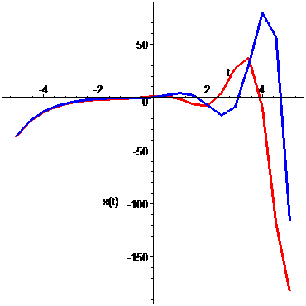

(d)

> **sist:=diff(x(t),t)=-x(t)+3*y(t)+3*z(t)+27*t^2,diff(y(t),t)=2*x(t)-2*y(t)-5*z(t)+3*t,diff(z(t),t)=-2*x(t)+3*y(t)+6*z(t)+3;**



> **cond_in:=x(0)=50,y(0)=-30,z(0)=26;**



> **xx1:=DEplot([sist],[x,y,z],t=-5..5,[[cond_in]], linecolor=blue,**

**scene=[t,x(t)]):**

> **yy1:=DEplot([sist],[x,y,z],t=-5..5,[[cond_in]],linecolor=red,**

**scene=[t,y(t)]):**

> **zz1:=DEplot([sist],[x,y,z],t=-5..5,[[cond_in]],linecolor=yellow,**

**scene=[t,z(t)]):**

> **display([xx1,yy1,zz1]);**

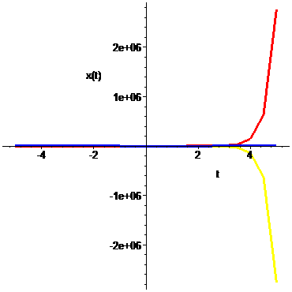

(3)

(a + b)

> **sist:=diff(x(t),t)=x(t)+y(t),diff(y(t),t)=-2*x(t)+4*y(t);**



> **cond_in:=x(0)=3,y(0)=0;**



> **sol:=dsolve({sist,cond_in},{x(t),y(t)});**



> **limit(sol[1],t=infinity);**



> **limit(sol[2],t=infinity);**



> **cond_in:=x(0)=2,y(0)=3;**



> **sol:=dsolve({sist,cond_in},{x(t),y(t)});**



> **limit(sol[1],t=infinity);**



> **limit(sol[2],t=infinity);**



> **cond_in:=x(0)=-3,y(0)=0;**



> **sol:=dsolve({sist,cond_in},{x(t),y(t)});**



> **limit(sol[1],t=infinity);**



> **limit(sol[2],t=infinity);**



> **cond_in:=x(0)=-2,y(0)=-3;**



> **sol:=dsolve({sist,cond_in},{x(t),y(t)});**



> **limit(sol[1],t=infinity);**



> **limit(sol[2],t=infinity);**



(c)

> **sist:=diff(x(t),t)=x(t)+y(t),diff(y(t),t)=-2*x(t)+4*y(t);**



> **DEplot([sist],[x(t),y(t)],t=-4..4,x=-10..10,y=-10..10,**

**[[x(0)=3,y(0)=0], [x(0)=2,y(0)=3], [x(0)=-3,y(0)=0], [x(0)=-2,y(0)=-3]], arrows=medium, linecolor=blue);**

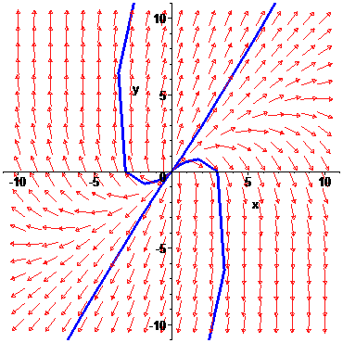

(4)

> **sist:=diff(x(t),t)=y(t),diff(y(t),t)=-x(t)-2*y(t);**



> **sol:=dsolve({sist},{x(t),y(t)});**



> **limit(sol[1],t=infinity);**



> **limit(sol[2],t=infinity);**



> **DEplot([sist],[x(t),y(t)],t=-4..4,x=-10..10,y=-10..10,**

**[[x(0)=3,y(0)=0], [x(0)=2,y(0)=3], [x(0)=-3,y(0)=0], [x(0)=-2,y(0)=-3]], arrows=medium, linecolor=blue);**

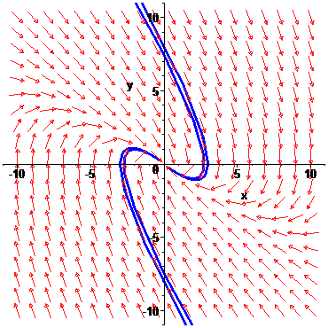

(5)

(a)

> **sist:=diff(x(t),t)=2*x(t)+y(t),diff(y(t),t)=x(t)+2*y(t);**



> **DEplot([sist],[x(t),y(t)],t=-4..4,x=-10..10,y=-10..10,**

**[[x(0)=3,y(0)=0], [x(0)=2,y(0)=3], [x(0)=-3,y(0)=0], [x(0)=-2,y(0)=-3]], arrows=medium, linecolor=blue);**

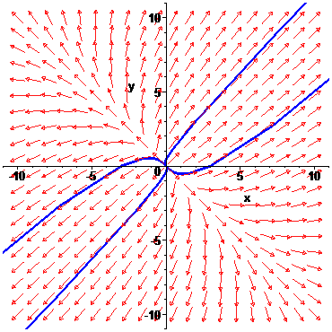

Nu are loc.

(b)

> **sist:=diff(x(t),t)=-x(t)-y(t),diff(y(t),t)=x(t)-y(t);**



> **DEplot([sist],[x(t),y(t)],t=-4..4,x=-10..10,y=-10..10,**

**[[x(0)=3,y(0)=0], [x(0)=2,y(0)=3], [x(0)=-3,y(0)=0], [x(0)=-2,y(0)=-3]], arrows=medium, linecolor=blue);**

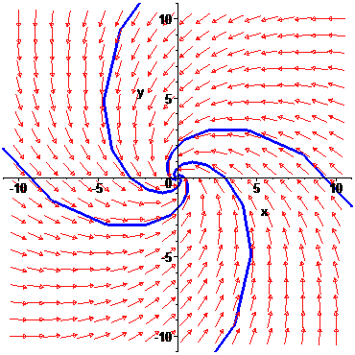

Are loc.

(c)

> **sist:=diff(x(t),t)=y(t),diff(y(t),t)=-x(t);**



> **DEplot([sist],[x(t),y(t)],t=-4..4,x=-10..10,y=-10..10,**

**[[x(0)=3,y(0)=0], [x(0)=2,y(0)=3], [x(0)=-3,y(0)=0], [x(0)=-2,y(0)=-3]], arrows=medium, linecolor=blue);**

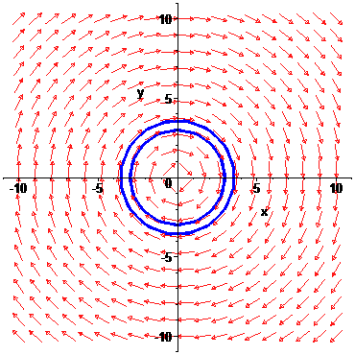

Are loc daca si numai daca x(0)=0 si y(0)=0.

(d)

> **sist:=diff(x(t),t)=-2*x(t),diff(y(t),t)=-4*x(t)-2*y(t);**



> **DEplot([sist],[x(t),y(t)],t=-4..4,x=-10..10,y=-10..10,**

**[[x(0)=3,y(0)=0], [x(0)=2,y(0)=3], [x(0)=-3,y(0)=0], [x(0)=-2,y(0)=-3]], arrows=medium, linecolor=blue);**

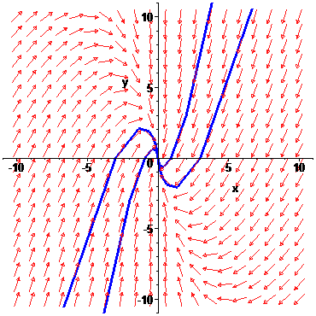

Are loc.

(e)

> **sist:=diff(x(t),t)=x(t)-4*y(t),diff(y(t),t)=5*x(t)-3*y(t);**



> **DEplot([sist],[x(t),y(t)],t=-4..4,x=-10..10,y=-10..10,**

**[[x(0)=3,y(0)=0], [x(0)=2,y(0)=3], [x(0)=-3,y(0)=0], [x(0)=-2,y(0)=-3]], arrows=medium, linecolor=blue,stepsize=1/100);**

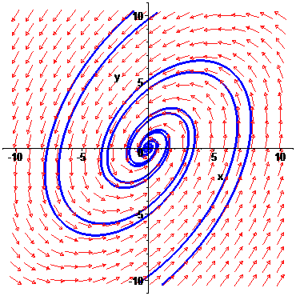

Are loc.

(f)

> **sist:=diff(x(t),t)=3*x(t)-y(t),diff(y(t),t)=y(t);**



> **DEplot([sist],[x(t),y(t)],t=-4..4,x=-10..10,y=-10..10,**

**[[x(0)=3,y(0)=0], [x(0)=2,y(0)=3], [x(0)=-3,y(0)=0], [x(0)=-2,y(0)=-3]], arrows=medium, linecolor=blue);**

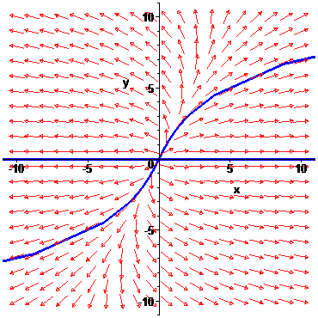

Nu are loc.